SPC Charts (Statistical Process Control)

A QI Help Guide

What is an SPC chart?
Statistical Process Control (SPC) charts help you understand how a process is performing over time. Rather than comparing “before and after”, SPC shows whether changes lead to real, sustained improvement or are simply normal variation.
SPC charts are widely used across the NHS for quality improvement, patient safety and assurance.
The most important rule
SPC = data over time
- Data collected daily, weekly, or monthly
- Plotted in time order
- Reviewed regularly
Examples of measures:
- Number of incidents per week
- % of patients seen within target
- Average length of stay
- Waiting time in minutes
If you are measuring data over time, you are doing SPC.
Why SPC charts are useful

Improvement:
SPC helps you answer:
- Did the change we tested make a difference?
- When did improvement start?
- Has it been sustained?
Assurance:
SPC helps you see:
- Is the process stable?
- Are we seeing unwarranted variation?
- Do we need to take action or provide reassurance?
SPC supports learning and decision‑making, not blame.

How SPC fits with the Model for Improvement
Model for Improvement
- What are we trying to accomplish?
- How will we know a change is an improvement?
- What changes can we make that will result in improvement?
SPC charts answer question 2
They allow you to:
- Track your outcome or process measure
- Annotate when changes (PDSA cycles) were tested
- Learn what works, and what doesn’t

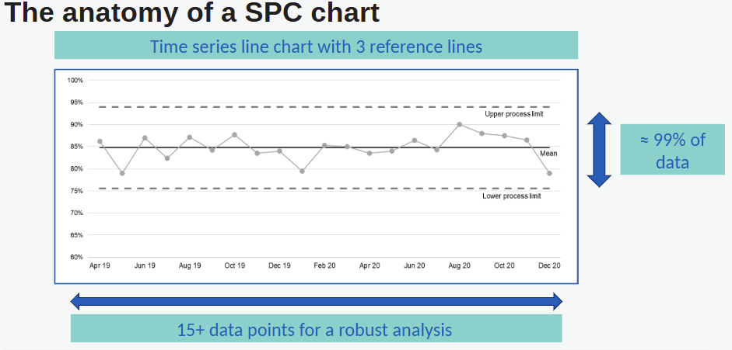

Key Parts of an SPC Chart
- Data points – measurements over time
- Centre line – the process average (mean or median)
- Upper and lower control limits – expected range of variation
- Time on the x-axis – shows trends and shifts
These features help separate signal from noise.

What tool should I use?
You have several options available within the NHS. Choose what works best for your project and confidence level.
Excel (Line Chart)
- Easy and accessible
- Good for early QI work
- Better than snapshots or audits

NHS SPC Tool (Excel‑based)
- Automatically calculates control limits
- Applies SPC rules
- Recommended for more advanced analysis

LifeQI
- Web‑based QI platform used across the trust and NHS.
- Allows you to:
  - Track measures over time
  - Display run charts and SPC charts
  - Link measures directly to aims, Driver Diagrams and PDSAs within your project or programme
  - Share progress with teams and sponsors

- All tools are acceptable as long as you are:
- Measuring data over time
- Reviewing it regularly
- Using it to learn and improve

Good practice tips
- Use the same data definition each time
- Measure little and often
- Plot data as it is collected
- Annotate when changes were tested
- Use the chart to support team discussion

Key message
You don’t need to be a statistician.
If you are collecting data over time and using it to learn, you are already doing effective Quality Improvement.

Useful links and resources
Create an account on the Futures site - Update Profile - Home page - Futures
And join the ‘Making Data Count’ workspace. Here you will be able to access this excellent 1 hour training (and others) but do watch it from it from Step 1. You can also download the SPC and Mult SPC tool here.
Step 1 Introduction to Making Data Count 13 January 2026 - Making Data Count - Futures
If you would like access to Life QI, please contact the QI team for access and submit your project via Hornbill. Quality Improvement - West Suffolk NHS Intranet

