Example Sensory Circuit
These activities are for examples only and may not be suitable for every child.
START
FINISH

Calming Activities
Organising Activities
Alerting Activities

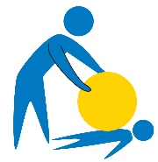
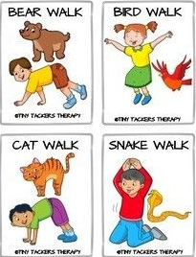
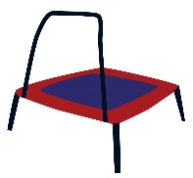

Jumping
Ball squash
Animal walks

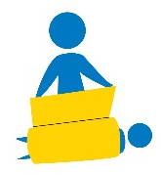

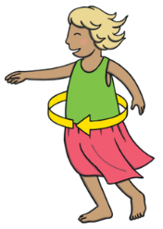

Spinning
Ball roll
Blanket wrap

