

CONTINENCE PROMOTION ASSESSMENT
Child’s Name: | Date of Birth:  NHS No:
Diagnosis: | Medication:
Reason for assessment: (routine, review, annual or referral) | Allergies:
Assessment completed by: | Date:

- Tell me what toileting is like for your child? What’s a typical day for you?
_________________________________________________________________________
_________________________________________________________________________
_________________________________________________________________________
_________________________________________________________________________
- Have you tried toilet training before? If so, what happened? How old was your child?
_________________________________________________________________________
_________________________________________________________________________
_________________________________________________________________________
_________________________________________________________________________

- What happens about toileting at School?
_________________________________________________________________________
_________________________________________________________________________
_________________________________________________________________________
_________________________________________________________________________

Bladder function – bladder emptied | Tick | Notes
1 More than once per hour
2 Between 1-2 hourly
3 More than 2 hourly

If night-time wetting occurs | Tick | Notes
1 Frequently, ie every night
2 Occasionally ie has odd dry night
3 Never

Bladder control | Tick | Notes
1 Never or rarely passes urine on toilet/potty
2 Passes urine on toilet sometimes
3 Passes urine on toilet every time
4 Can initiate a void on request

Sitting on the toilet | Tick | Notes
1 Afraid or refuses to sit
2 Sits with distraction or encouragement
3 Sits briefly with or without toilet adaptation
4 Sits long enough to complete voiding or bowel action

Going to the toilet | Tick | Notes
1 Gives no indication of need to go to the toilet
2 Gives some indication of need to go to the toilet
3 Sometimes goes to or indicates need for toilet of own accord

Handling clothes at toilet | Tick | Notes
1 Cannot handle clothes at all
2 Attempts or helps to pull pants down
3 Pulls pants down by self (if physically able)
4 Pulls clothes up and down without help

Behaviour problem, that interferes with toileting process eg screams when toileted, faecal smears | Tick | Notes
1 Occurs frequently
2 Occurs occasionally, ie less than once a day
3 Never occurs

Wears pads, disposable pants or similar | Tick | Notes
1 Yes

2 No

Toilet | Tick | Notes
1 Requires toileting aids or adaptations
2 Uses normal toilet/potty

Response to basic commands, eg ‘come here’ | Tick | Notes
1 Never responds to commands
2 Occasionally responds
3 Always responds

Diet | Tick | Notes
1 Refuses/unable to eat any fruit/veg
2 Will occasionally eat fruit/veg each day
3 Eats adequate amount

Suggested daily intake of drinks for children& young people (Bladder & Bowel UK/ ERIC produced by Ferring Pharmaceuticals 2020)

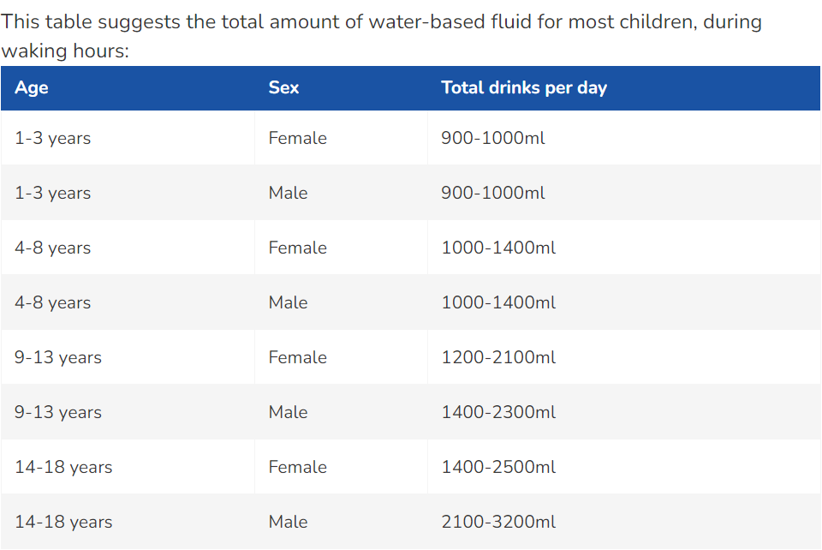

Suggested intake of water-based drinks per 24 hours according to age and sex (NICE2010)
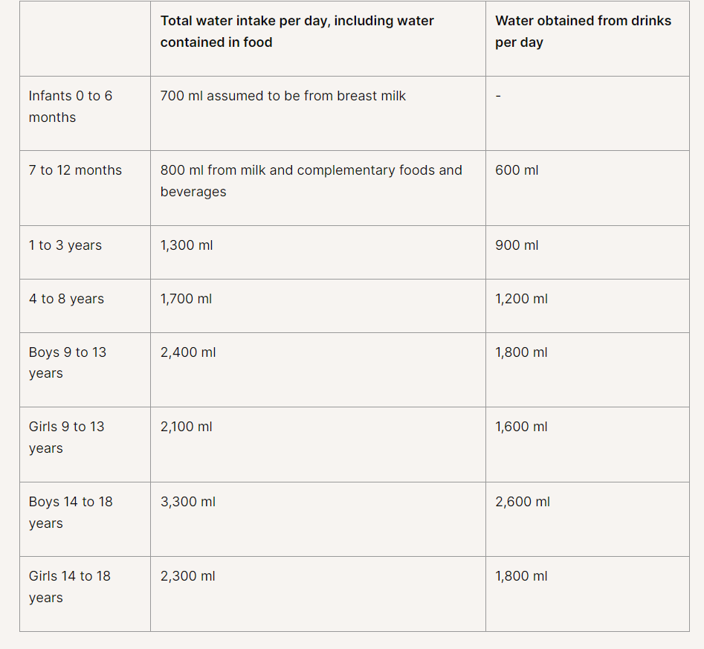
Please note: Children and Young People should drink more on hot days or when they are physically active
Fluid intake | Tick | Notes
1 Drinks little (sips, small drinks or less than 3 good drinks)
2 Drinks moderate amount (4-5 small to medium drinks)
3 Drinks good amount (6+ good size) drinks

Bowel function | Tick | Notes
1 Has more than three bowel actions per day
2 Does not always have normally formed bowel movements ie is subject to constipation or diarrhoea
3 Has regular normally formed bowel movements

Night-time bowel movements | Tick | Notes
1 Occur frequently ie every night
2 Occur occasionally ie has some clean nights
3 Never occurs

Bowel control | Tick | Notes
1 Never or rarely opens bowels on toilet/potty
2 Opens bowels on toilet sometimes
3 Opens bowels on toilet every time

Constipation | Yes | No
Does the child or young person have a bowel movement (poo) fewer
than three times a week (stool type 3 or 4)?
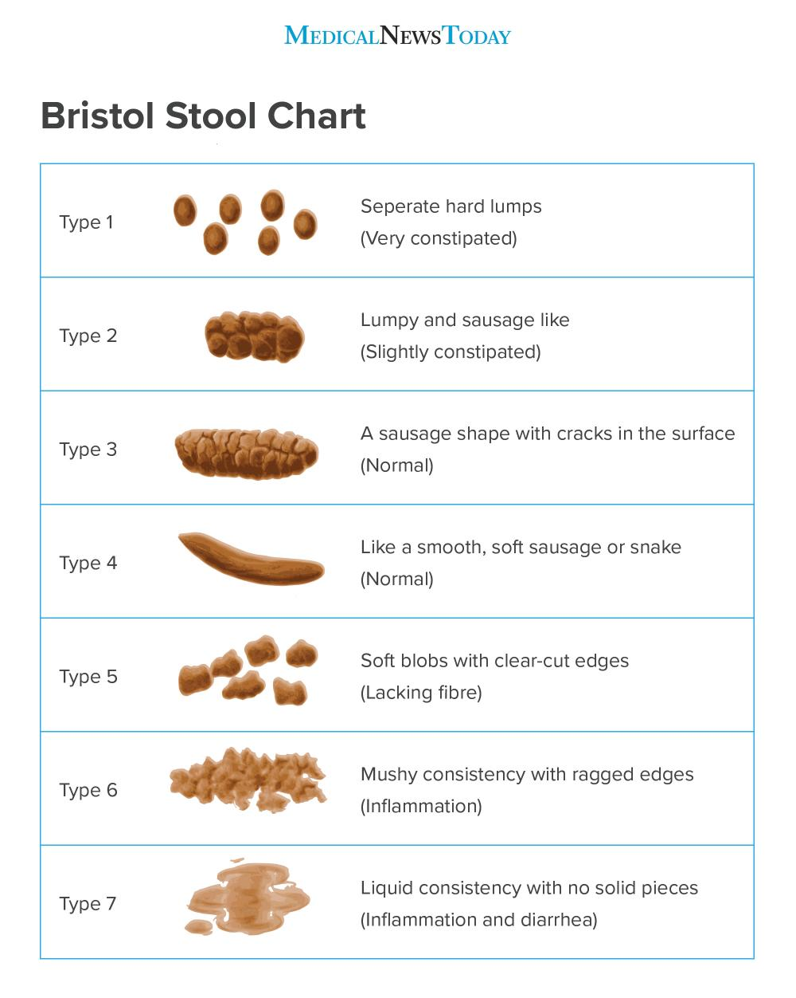 | Which type?
Have you noticed any soiling (very loose, very smelly stool passed
without sensation) in recent days?
Does the child/young person have poor appetite that improves with
the passage of a large stool?
Does the child or young person experience abdominal pain that comes
and goes with the passage of stool?
 | Yes | No
Is there evidence of retentive posturing typically straight-legged,
tiptoed, back arching posture)?

Does the child or young person experience anal pain?

Has the child or young person had any previous episodes of
constipation or the present symptoms?
Have you noticed any cracks or tears in the anal region?

Does the child or young person bleed when passing stools?

More than 2 ‘yes’ above indicates constipation

SUMMARY
ACTION PLAN FOR CONSTIPATION
 | Yes | No
Indicates constipation

If ‘yes’ to above
Advise parent/carer to go to GP

Task GP

ACTION PLAN FOR CONTINENCE PROMOTION
 | Yes | No
Send a copy of assessment to parent/carer

Consent given to share data with Provider

Copy attached to SystmOne

Equipment/aids suggested

Other interventions e.g. use of visuals, product assessment, next review date

Parent/carer/young person plan

