Sensory Processing – What is it?
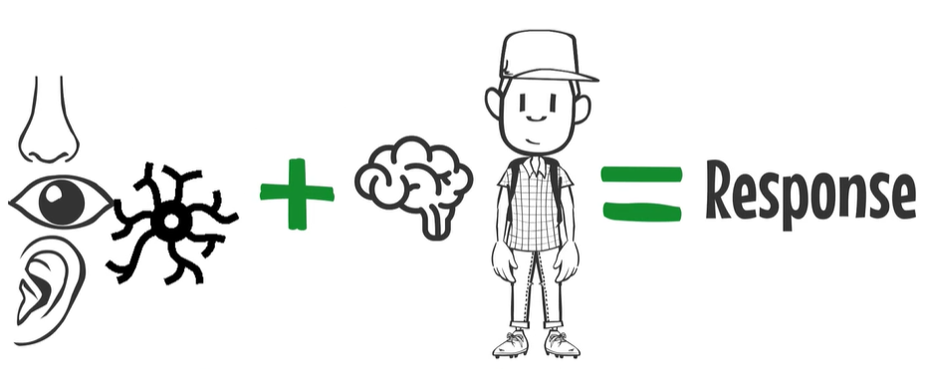
Sensory processing is the way our bodies receive information from our environment or from inside our body. This information travels through our nervous system to our brain to process and make sense of it. The brain will then tell the body to do something about the message. This affects the way we move, behave or respond.

We have 8 sensory systems which help us notice sensory experiences in the world around us and from inside our bodies.
Our sensory systems are:
 | Vision | - What we see around us through our eyes | These sensory systems tell us about our environment.  They are sometimes called out external sensory systems.
 | Sounds / hearing | - What we hear around us through our ears
 | Taste | - What we taste in our mouth
 | Smell | - What we smell through our nose
 | Touch | - What we feel on our skin. It helps us feel and learn from our environment. It allows us to interact with our surroundings.
 | Body awareness (Proprioception) | - Messages sent from our muscles and joints helping us know how close our body is to other people and objects. | These sensory systems tell us about our body.  They are sometimes called our internal sensory systems
 | Movement (Vestibular) | - Messages sent from inside our inner ear helping us know how fast and which way we are moving
 | Internal feelings (Interoception) | - Messages sent from inside our body helping us know how we feel, like feeling hungry or feeling worried

How Does Sensory Procesing Happen?
A sensory system ‘notices’ a sensory experience.


When these sensory systems ‘notice’ sensory messages they send them to our brain.

Our brain listens to the messages and decides what it needs to do about it.

Sometimes our brain might respond really quickly (this might be referred to as being hypersensitive).   | Other times it might respond slowly or not at all (this might be referred to as being hyposensitive).  
Depending on how the brain responds depends on whether we may like or dislike the sensation.

These are what we call our
Sensory Preferences
Sensory preferences can influence how we act and manage everyday tasks.

